Tip: Converting Between Datatypes

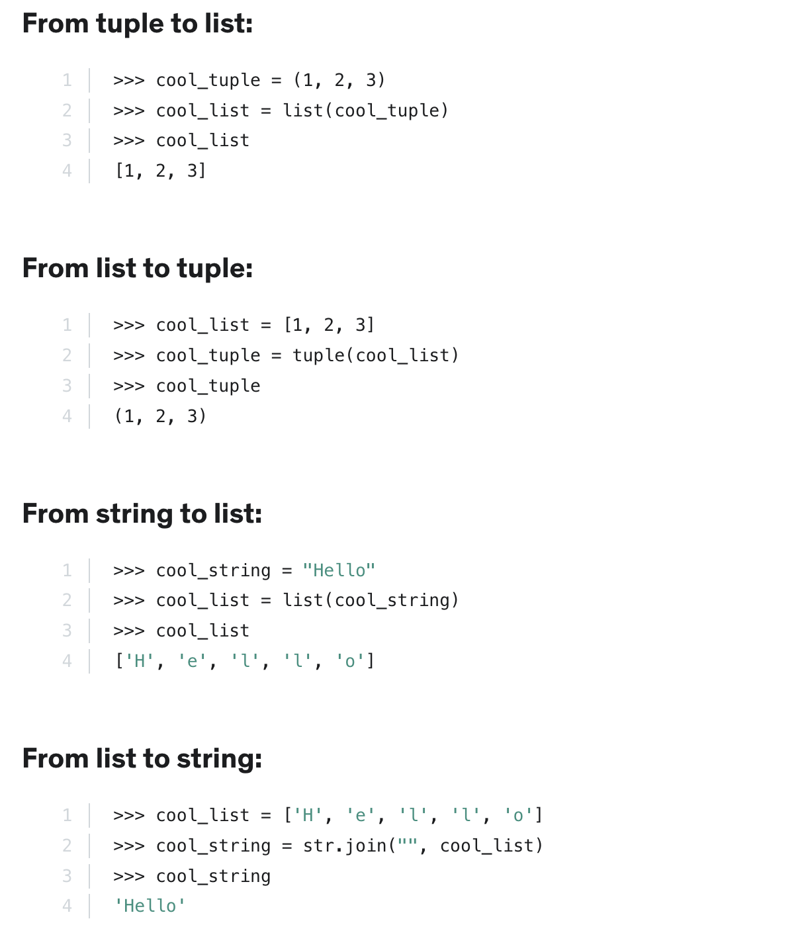
Sometimes you might need to convert between different data types in Python for one reason or another. That is very easy to do:
As can be seen above, converting a list into a string is more complex. Here str() is not sufficient. We need str.join(). Try running the code above again, but this time using str.join("---", cool_list) in the second line. You will understand how str.join() works.

